Heal Somerset
Appendix to Micro moth report 2024
Jenny Vickers
The following presents a list of macro moths and other taxa recorded on site while undertaking my micro-moth survey work in 2024. All records have been sent to the relevant recording scheme or iRecord.

ODONATA – Dragonflies and Damselflies
Calopteryx virgo Beautiful Demoiselle
Pyrrhosoma nymphula Large Red Damselfly
Coenagrion puella Azure Damselfly
Sympetrum striolatum Common Darter
Libellula depressa Broad-bodied Chaser
Orthetrum cancellatum Black-tailed Skimmer

ORTHOPTERA – Grasshoppers and Bush-crickets
Metrioptera roeselii Roesel’s Bush-cricket
Leptophyes punctatissima Speckled Bush-cricket
Pholidoptera griseoaptera Dark Bush-cricket
Conocephalus discolor Long-winged Conehead
Pseudochorthippus parallelus Meadow Grasshopper
Chorthippus brunneus Field Grasshopper

DERMAPTERA – Earwigs
Forficula auricularia Common Earwig

PHILOSCIIDAE- Woodlice
Oniscus asellus Common Shiny Woodlouse
Philoscia muscorum Common Striped Woodlouse

HEMIPTERA - Bugs
Dolycoris baccarum Hairy Shieldbug
Palomena prasina Green Shieldbug
Acanthosoma haemorrhoidale Hawthorn Shieldbug
Pentatoma rufipes Red-legged Shieldbug
Eysarcoris venustissimus Woundwort Shieldbug
Elasmucha grisea Parent Shieldbug
Eurygaster testudinaria Tortoise Shieldbug
Coreus marginatus Dock Bug
Nabis limbatus Marsh Damsel Bug
Deraeocoris ruber A Plant Bug
Dryophilocoris flavoquadrimaculatus A Plant Bug
Orthops campestris A Plant Bug
Rhabdomiris striatellus Striped Oak Bug
Leptopterna dolabrata Meadow Plant Bug
Notostira elongata A Mirid Bug
Philaenus spumarius Common Froghopper
Cercopis vulnerata Red-and-black Froghopper
Aphrophora alni Alder Spittlebug
Lichtensia viburni A Scale Insect – on Hedera helix

COLEOPTERA – Beetles
Cantharis flavilabris A Soldier Beetle
Cantharis rustica A Soldier Beetle
Rhagonycha fulva Common Red Soldier Beetle
Malachius bipustulatus Common Malachite
Coccinella septempunctata 7-spot Ladybird – adults and pupa
Adalia decempunctata 10-spot Ladybird
Propylea quattuordecimpunctata 14-spot Ladybird
Tytthaspis sedecimpunctata 16-spot Ladybird
Psyllobora vigintiduopunctata 22-spot Ladybird
Subcoccinella vigintiquattuorpunctata 24-spot Ladybird
Calvia quatuordecimguttata Cream-spot Ladybird
Harmonia axyridis Harlequin Ladybird
Oedemera nobilis Swollen-thighed Beetle
Oedemera lurida A False Blister Beetle
Pyrochroa serraticornis Red-headed Cardinal Beetle
Grammoptera ruficornis Common Grammoptera
Rutpela maculata Black-and-yellow Longhorn Beetle
Clytus arietis Wasp Beetle
Agelastica alni Alder Leaf Beetle
Chrysolina herbacea Mint Leaf Beetle
Gastrophysa viridula Green Dock Beetle
Cassida rubiginosa A Tortoise Beetle
Cassida vibex A Tortoise Beetle
Apoderus coryli Hazel Leaf-roller Weevil
Phyllobius pomaceus Green Nettle Weevil
Curculio venosus A Weevil – found under Quercus robur (Oak)
Orchestes hortorum Beetle mine on Quercus robur (Oak)
Orchestes pilosus Beetle mine on Quercus robur (Oak)
Rhamphus oxyacanthae Beetle mine on Crataegus monogyna (Hawthorn)
Rhamphus pulicarius Beetle mine on Salix cinerea (Sallow)

MECOPTERA – Scorpion Flies
Panorpa communis Scorpion Fly – male, genital callipers examined

LEPIDOPTERA - Macro Moths
54.009 Zygaena lonicerae Narrow-bordered Five-spot Burnet – larva
66.003 Malacosoma neustria Lackey – larva on Prunus spinosa
66.010 Euthrix potatoria Drinker – larva on Rubus fruticosus agg.
69.003 Laothoe populi Poplar Hawk-moth – light trap
69.007 Sphinx pinastri Pine Hawk-moth – light trap
69.016 Deilephila elpenor Elephant Hawk-moth – light trap
70.006 Earophila badiata Shoulder Stripe – larva on Lonicera periclymenum
70.029 Timandra comae Blood-vein – light trap
70.045 Scotopteryx chenopodiata Shaded Broad-bar – adults in the field
70.054 Xanthorhoe montanata Silver-ground Carpet – light trap
70.094 Ecliptopera silaceata Small Phoenix – light trap
70.106 Operophtera brumata Winter Moth – larva from Rosa canina
adult emerged 14/12
70.207 Lomaspilis marginata Clouded Border – larva on Salix caprea
70.226 Opisthograptis luteolata Brimstone Moth – larva in the field and light trap
70.235 Ennomos fuscantaria Dusky Thorn – light trap
70.241 Crocallis elinguaria Scalloped Oak – light trap
70.246 Apocheima hispidaria Small Brindled Beauty – light trap
70.251 Biston strataria Oak Beauty – light trap
70.258 Peribatodes rhomboidaria Willow Beauty – light trap
70.270 Ectropis crepuscularia The Engrailed – larva on Euonymus europaeus
70.283 Campaea margaritaria Light Emerald – light trap
71.003 Cerura vinula Puss Moth – larva on Salix cinerea
71.013 Notodonta ziczac Pebble Prominent – light trap
71.017 Pheosia tremula Swallow Prominent – light trap
71.018 Pheosia gnoma Lesser Swallow Prominent – light trap
71.020 Pterostoma palpina Pale Prominent – light trap
71.021 Ptilodon capucina Coxcomb Prominent – light trap
71.025 Phalara bucephala Buff-tip – larva in the field and light trap
72.001 Scoliopteryx libatrix The Herald – larva on Salix sp (long leaved)
72.002 Rivula sericealis Straw Dot – adults in the field
72.019 Spilosoma lutea Buff Ermine – light trap
72.020 Spilosoma lubricipeda White Ermine – light trap
72.024 Phragmatobia fuliginosa Ruby Tiger – adult in the field
72.044 Eilema griseola Dingy Footman – light trap
72.045 Eilema lurideola Commo Footman – light trap
72.046 Eilema complana Scarce Footman – light trap
73.012 Diachrysia chrysitis Burnished Brass f aurea – light trap
73.022 Plusia festucae Gold Spot – light trap
73.045 Acronicta rumicis Knot Grass – larva in the field and light trap
73.048 Panemeria tenebrata Small Yellow Underwing – adults in the field
73.069 Xylocampa areola Early Grey – light trap
Hoplodrina sp Uncertain/Rustic agg.
73.099 Hoplodrina ambigua Vine’s Rustic – light trap
73.120 Eremobia ochroleuca Dusky Sallow – light trap
73.123 Hydraecia micacea Rosy Rustic – light trap
73.136 Nonagria typhae Bulrush Wainscot – light trap
73.162 Apamea monoglypha Dark Arches – light trap
Mesapamea sp Common/Lesser Common Rustic agg
Oligia strigilis Marbled Minor agg. – light trap
73.189 Agrochola lota Red-line Quaker – larva on Salix cinerea 24/04
adult emerged 15/09
73.242 Orthosia incerta Clouded Drab – light trap
73.244 Orthosia cerasi Common Quaker – light trap
73.245 Orthosia cruda Small Quaker – light trap
73.249 Orthosia gothica Hebrew Character – light trap
73.267 Lacanobia oleracea Bright-line Brown-eye – light trap
73.293 Mythimna impura Smoky Wainscot – light trap
73.334 Diarsia rubi Small Square-spot – light trap
73.348 Noctua janthe Lesser Broad-bordered Yellow Underwing – trap
73.358 Xestia sexstrigata Six-striped Rustic – light trap

LEPIDOPTERA - Butterflies
Thymelicus sylvestris Small Skipper
Ochlodes sylvanus Large Skipper
Anthocharis cardamines Orange-tip
Pieris rapae Small White
Pararge aegeria Speckled Wood
Melanargia galathea Marbled White
Maniola jurtina Meadow Brown
Pyronia tithonus Gatekeeper
Aphantopus hyperantus Ringlet
Vanessa Atalanta Red Admiral
Aglais io Peacock
Aglais urticae Small Tortoiseshell
Polygonia c-album Comma
Callophrys rubi Green Hairstreak

DIPTERA – Flies
Tipula maxima Giant Crane Fly
Tipula paludosa A Crane Fly
Tipula vernalis A Crane Fly
Tipula fascipennis A Crane Fly
Euphylidorea dispar A Crane Fly – det Mike Ashworth
Bibio marci St Mark’s Fly
Rhagio tringarius Marsh Snipefly
Chrysopilus cristatus Black Snipefly
Tabanus bromius Band-eyed Brown Horse Fly
Chloromyia formosa Broad Centurion
Oxycera rara Four-barred Major
Bombylius dilcolor Dotted Bee-fly
Dioctria rufipes Common Red-legged Robberfly
Empis livida A Dance Fly
Empis opaca A Dance Fly – det Mike Ashworth
Empis tessalata A Dance Fly
Poecilobothrus nobilitatus A Long-legged Fly
Melanostoma scalare Long-winged Duskyface Hoverfly
Platycheirus albimanus Grey-spotted Sedgesitter Hoverfly
Pyrophaena rosarum Fourspot Sedgesitter Hoverfly
Chrysotoxum bicinctum Two-banded Meadow Fly
Chrysotoxum cautum Large Meadow Fly – det Mike Ashworth
Xanthogramma pedissequum Superb Dayglower Hoverfly
Sphaerophora scripta Common Globetail Hoverfly
Leucozona leucorum Blotch-winged Whitebelt
Scaeva pyrastri White-bowed Smoothwing
Eupeodes latifasciatus Broad-banded Aphideater
Eupeodes luniger Lunuled Aphideater
Episyrphus balteatus Marmalade Hovefly
Epistrophe eligans Spring Smoothtail
Syrphus ribesii Common Flower Hoverfly
Cheilosia albitarsis Buttercup Blacklet
Cheilosia illustrata Bumblebee Blacklet
Rhingia campestris Common Snout Fly
Eristalis arbustorum Eurasian Drone Fly
Eristalis nemorum Stripe-faced Drone Fly
Eristalis pertinax Tapered Drone Fly
Eristalis tenax Common Drone Fly
Myathropa florea Common Batman Hoverfly
Helophilus pendulus Tiger Marsh Hoverfly
Volucella bombylans Bumblebee Plumehorn
Volucella pellucens Pied Plumehorn
Syritta pipiens Common Compost Fly
Xylota segnis Orange-belted Leafwalker
Chaetostomella cylindrica A Picture-winged Fly – emerged 12.05.2025 from Knapweed Seedhead
Terellia tussilaginis A Picture-winged Fly – emerged from Arctium sp seed head
Tephritis neesii A Picture-winged Fly – on Leucanthemum vulgare
Urophora stylata A Picture-winged Fly – emerged from Cirsium vulgare seed head
Urophora cardui A Picture-winged Fly – on Cirsium arvense
Coremacera marginata A Snail Killing Fly
Euthycera fumigata A Snail Killing Fly
Xyphosia miliaria A Fruit Fly – on Cirsium arvense
Scathophaga stercoraria Yellow Dung-fly
Anthomyia procellaris Anthomyiid Fly
Norellisoma spinimanum A Dung-fly – det Mike Ashworth
Mesembrina meridiana Noon Fly
Nyctia halterata Dark-winged Flesh Fly – det Mike Ashworth
Phaonia pallida A Muscid Fly
Eriothrix rufomaculata A Parasitic Fly
Agromyza nana Fly mine on Trifolium repens (White Clover)
Agromyza albitarsis Fly mine on Populus tremula (Aspen)
Phytomyza agromyzina Fly mine on Cornus sanguinea (Dogwood)
Phytomyza ilicis Fly mine on Ilex aquifolium (Holly)
Phytobia cerasiferae An Agromyzid Fly – mine in stem of Prunus spinosa

HYMENOPTERA – Bees, Wasps and Ants
Calameuta filiformis A Sawfly
Tenthredo mesomela A Sawfly
Tenthredo temula A Sawfly
Nematus (Craesus) septentrionalis Sawfly larvae on Corylus avellana - det Ian Andrews
Periclist pubescens A Sawfly – larva – det Ian Andrews
Fenusa dohrnii Sawfly mine on Alnus glutinosa (Alder)
Fenusa pulmilla Sawfly mine on Betula pubescens (Downy Birch)
Fenusa ulmi Sawfly mine on Ulmus glabra (Wych Elm)
Profenusa pygmaea Sawfly mine on Quercus robur (Oak)
Heterarthrus wuestneii Sawfly mine on Acer campestre (Field Maple)
Enicospilus ramidulus Ichneuman wasp – adult – det Gavin Broad, iRecord
Rhyssa persuasoria Sabre Wasp – female
Vespa crabro Hornet
Andrena haemorrhoa Early Mining Bee
Bombus pascuorum Common Carder Bumblebee
Bombus pratorum Early Bumblebee
Bombus terrestris Buff-tailed Bumblebee – queen

ARACHNIDS – Spiders and Harvestmen
Araneus diadematus Garden Spider
PIsura mirabilis Nursery-wed Spider
Argiope bruennichi Wasp Spider, male, females and egg sacs
Leiobunum rotundum Harvestman
Phalangium opilio Harvestman
Dichranopalpus sp Harvestman

GALLS
Aceria eriobia Gall mite on Acer campestre (Field Maple)
Aceria fraxinivora Gall mite on Fraxinus excelsior (Ash)
Aceria macrochela Gall mite on Acer campestre (Field Maple)
Aceria myriadeum Gall mite on Acer campestre (Field Maple)
Aculus laevis Gall mite on Salix caprea (Goat Willow)
Eriophyes crataegi Gall mite on Crataegus monogyna (Hawthorn)
Eriophyes convolvens Gall mite on Euonymus europaeus (Spindle)
Eriophyes similis Gall mite on Prunus spinosa (Blackthorn)
Stenacis euonymi Gall mite on Euonymus europaeus (Spindle)
Euura bridgmanii Sawfly gall on Salix cinerea (Sallow)
Euura proxima Sawfly gall on Salix fragilis (Crack Willow)
Eupontania pedunculi Sawfly gall on Salix cinerea (Sallow)
Phyllocoptes goniothorax Gall mite on Crataegus monogyna (Hawthorn)
Andricus aries Sexual generation of gall wasp on Quercus robur (Oak)
Andricus foecundatrix Asexual generation of gall wasp on Quercus robur (Oak)
Andricus kollari/infectorius Asexual generation of gall wasp on Quercus robur (Oak)
Andricus quercuscalicis Asexual generation of gall wasp on Quercus robur (Oak)
Biorhiza pallida Sexual generation of gall wasp on Quercus robur (Oak)
Cynips quercusfolii Asexual generation of gall wasp on Quercus robur (Oak)
Cynips longiventris Asexual generation of gall wasp on Quercus robur (Oak)
Neuroterus anthacinus Asexual generation of gall wasp on Quercus robur (Oak)
Neuroterus albipes Asexual generation of gall wasp on Quercus robur (Oak)
Neuroterus numismalis Asexual generation of gall wasp on Quercus robur (Oak)
Neuroterus quercusbaccarum Asexual generation of gall wasp on Quercus orbur (Oak)
Diplolepis rosae Gall wasp on Rosa canina (Dog Rose)
Dasineura crataegi Gall midge on Crataegus monogyna (Hawthorn)
Dasineura fraxini Gall midge on Fraxinus excelsior (Ash)
Dasineura populeti Gall midge on Populus tremula (Aspen)
Dasineura pustulans Gall midge on Filipendula ulmaria (Meadowsweet)
Dasineura ulmaria Gall midge on Filipendula ulmaria (Meadowsweet)
Dasineura urticae Gall midge on Urtica dioica (Nettle)
Macrodiplosis pustularis Gall midge on Quercus robur (Oak)
Psyllopsis fraxini Psyllid gall on Fraxinus excelsior (Ash)
Tetraneura ulmi Fig Gall on Ulmus glabra (Wych Elm)
Phragmidium mucronatum Fungal gall on Rosa canina (Dog Rose)
Puccinia sessilis Rust on Arum Maculatum (Lords and Ladies)
Puccinia urticata Rust on Urtica dioica (Nettle)
Puccinia pulverulenta Rust on Epilobium hirsutum (Great Willowherb)
Melampsora euonymi-caprearum Rust on Euonymus europaeus (Spindle)
Farysia thuemenii Smut fungus on Carex pendula (Pendulus Sedge)
Taphrina alni Fungal gall on Alnus glutinosa (Alder)
Taphrina pruni Fungal gall on Prunus spinosa (Blackthorn)
Psyllopsis fraxini Psyllid gall on Fraxinus excelsior (Ash)

FUNGI
Panaeolus acuminatus det – Darren Gorden – FB
Daldinia concentrica King Alfred’s Cakes

For interest here are some photos of species recorded on site in 2024.

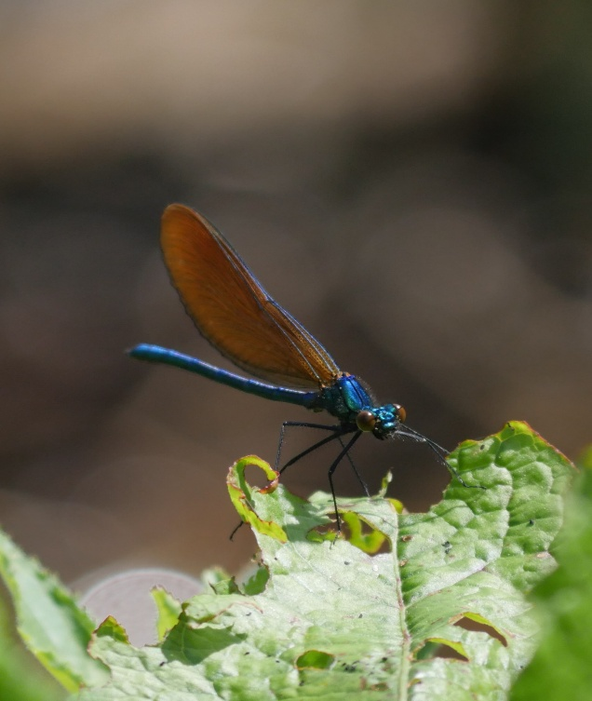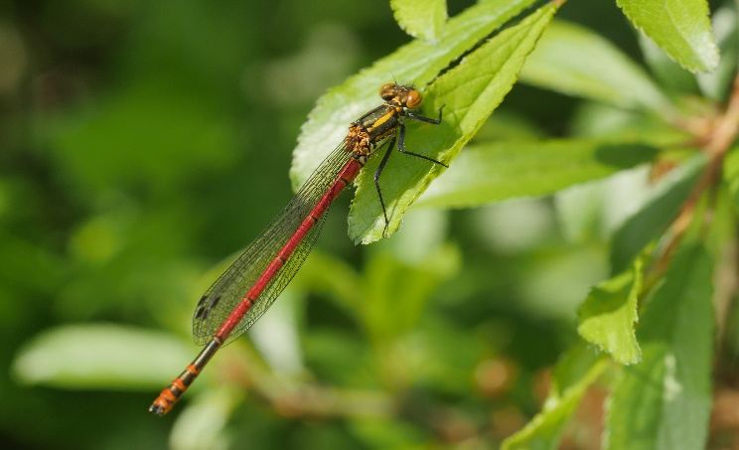
Calopteryx virgo (Beautiful Demoiselle) Pyrrhosoma nymphula (Large Red Damselfly)

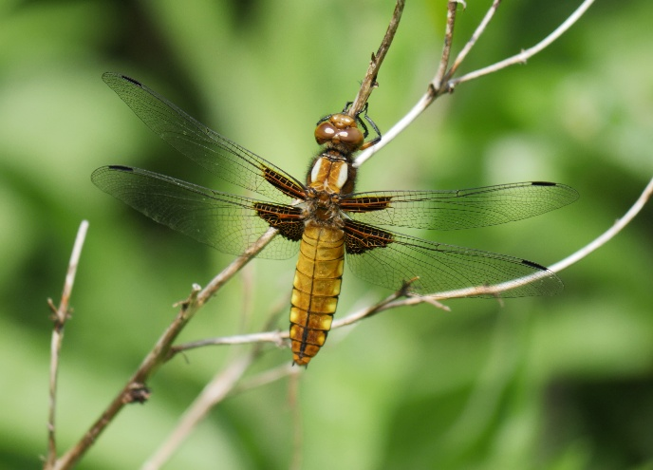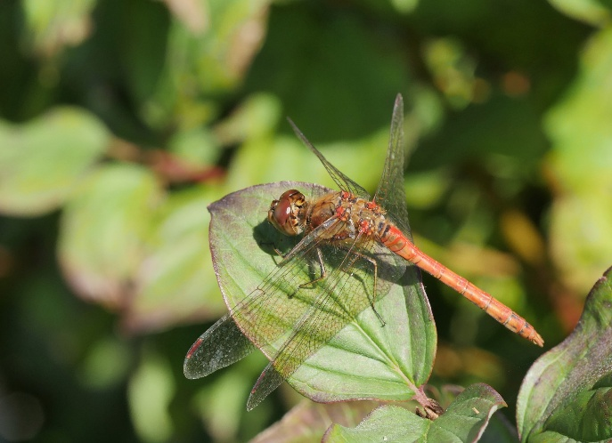
Libellula depressa (Broad-bodied Chaser) Sympetrum striolatum (Common Darter)

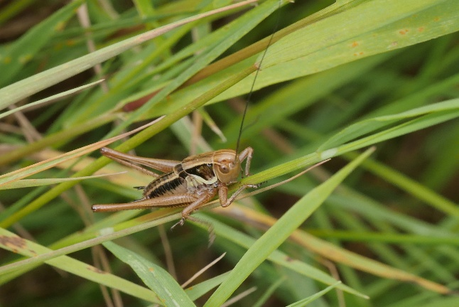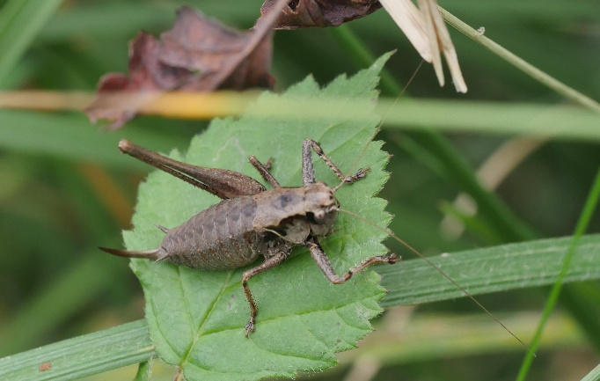
Metrioptera roeselii (Roesel’s Bush-cricket) Pholidoptera griseoaptera (Dark Bush-cricket)

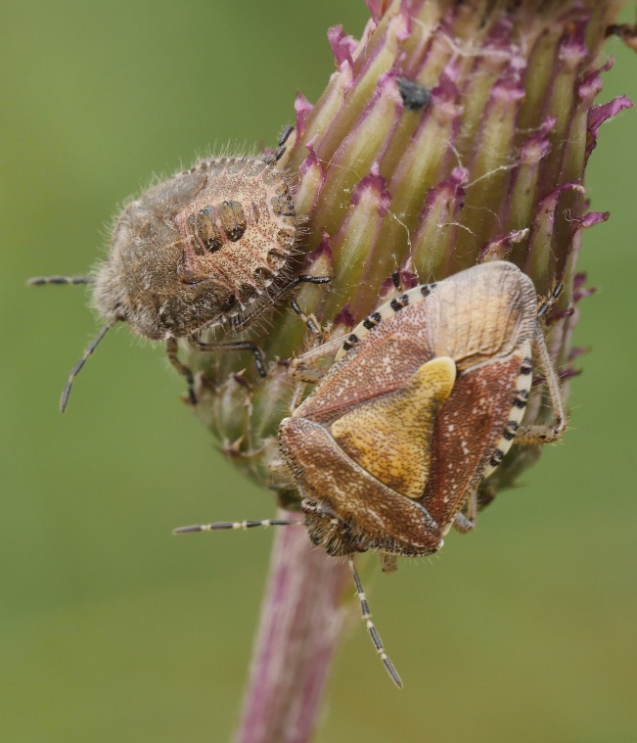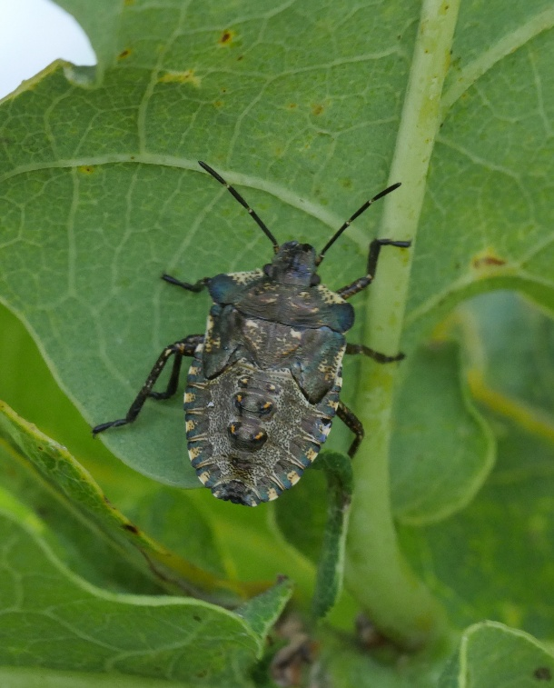
Dolycoris baccarum (Hairy Shieldbug) Pentatoma rufipes (Red-legged Shieldbug)
Adult and late instar final instar

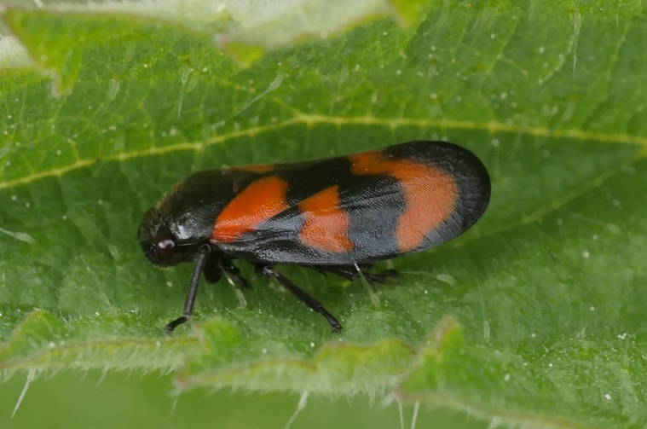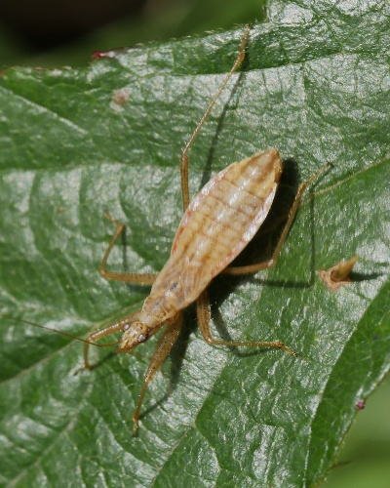
Cercopis vulnerata (Red-and-black-Froghopper) Nabis limbatus (Marsh Damsel Bug)

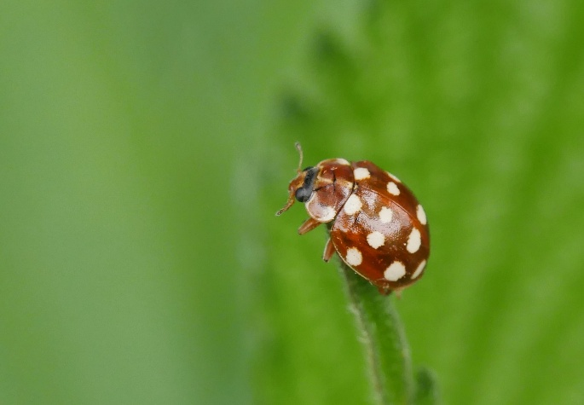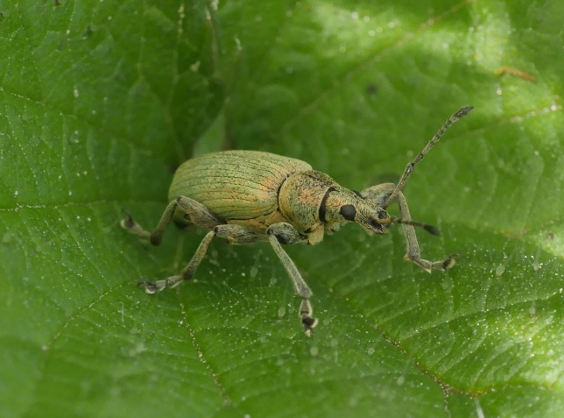
Calvia quatuordecimguttata (Cream-spot Ladybird) Phyllobius pomaceus (Green Nettle Weevil)

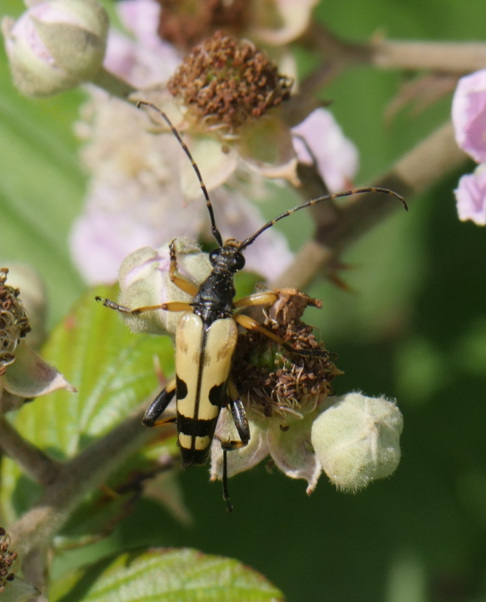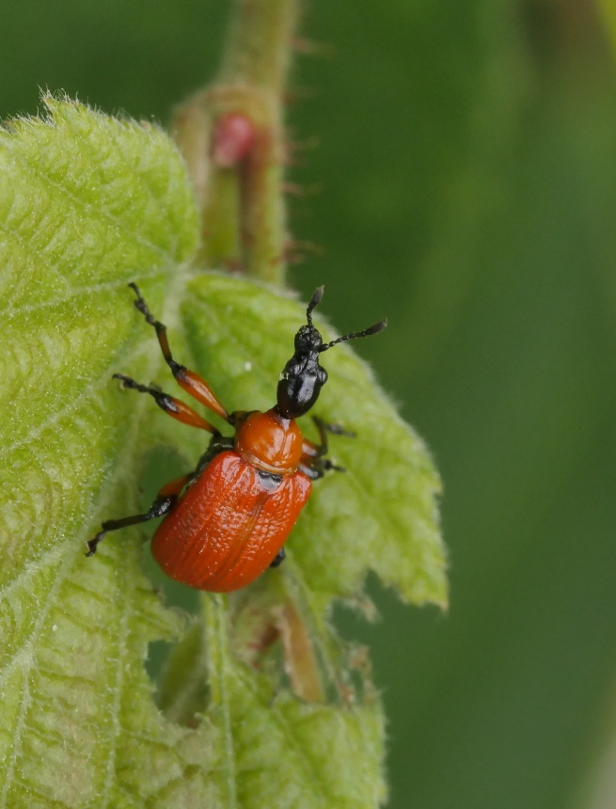
Rutpela maculata (Yellow-and-black Longhorn) Apoderus coryli (Hazel Leaf-roller Weevil)

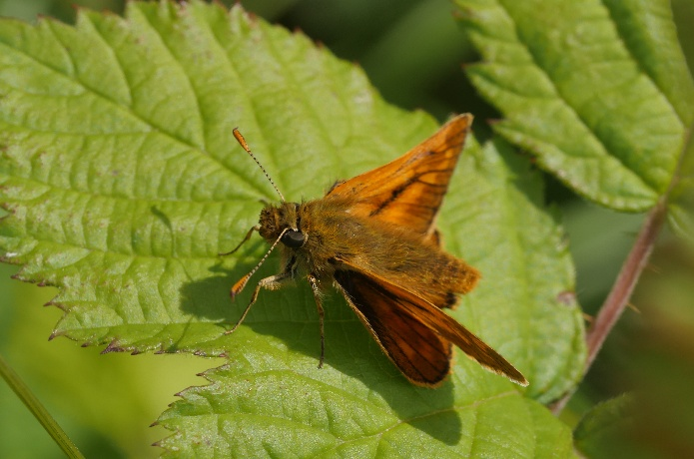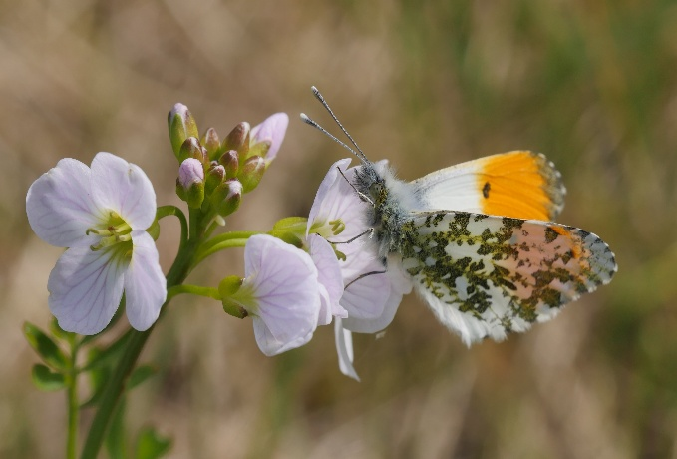
Ochlodes sylvanus (Large Skipper) male Anthocharis cardamines (Orange-tip) male

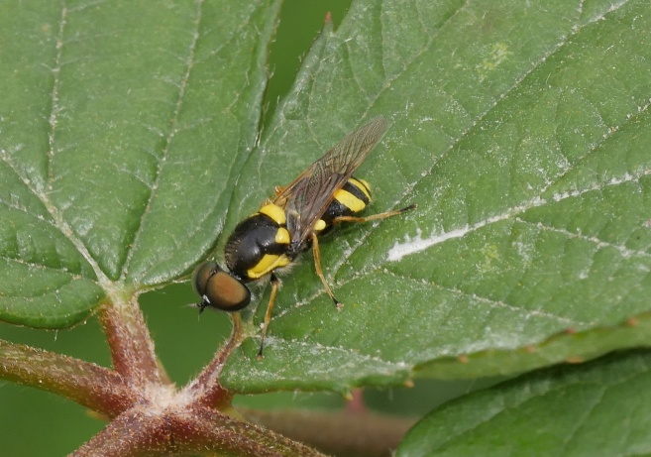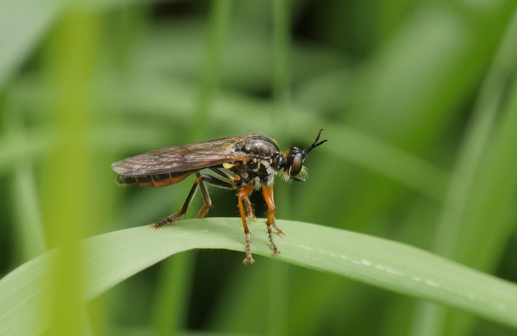
Oxycera rara (Four-barred Major) Dioctria rufipes (Common Red-legged Robberfly)

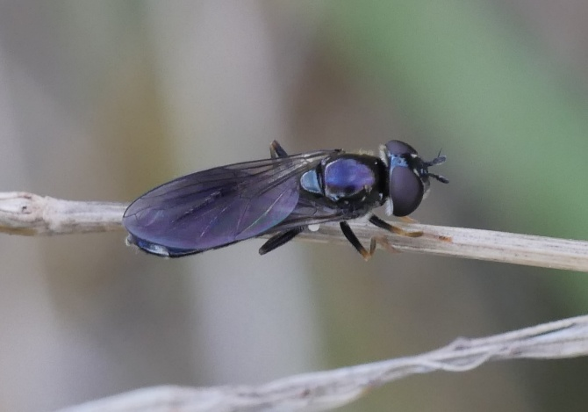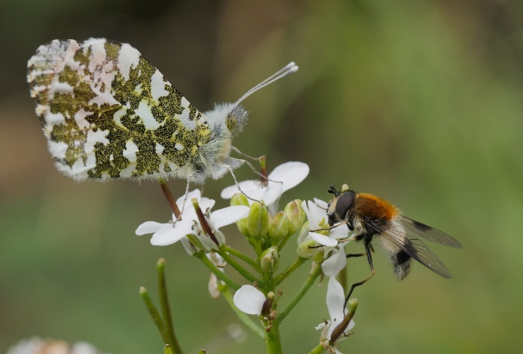
Pyrophaena rosarum (Four-spot Sedgesitter) Leucozona lucorum (Blotch-winged Whitebelt)

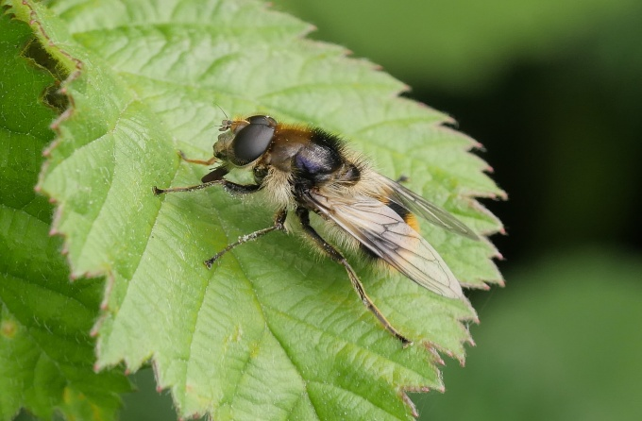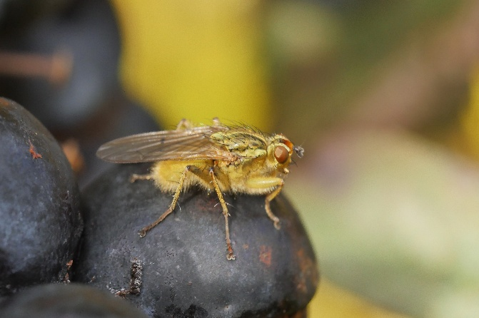
Cheilosia illustrata (Bumblebee Blacklet) Scathophaga stercoraria (Yellow Dungfly)

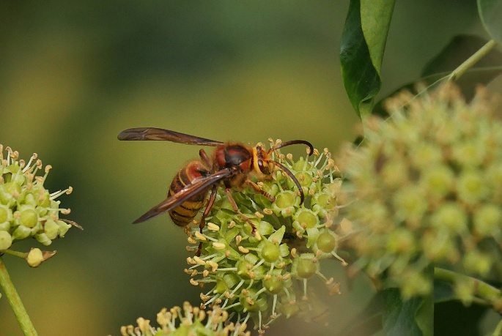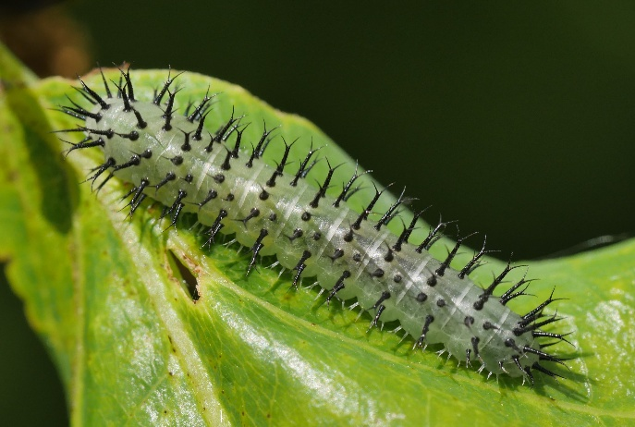
Vespa crabro (Hornet) Periclist pubescens (A Sawfly larva)
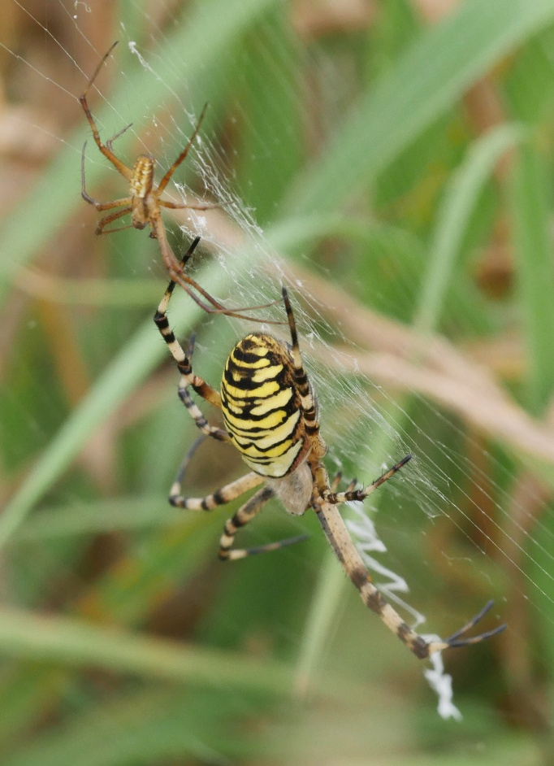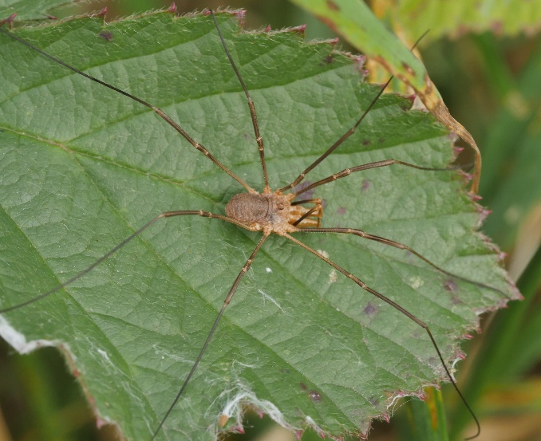
Argiope bruennichi (Wasp Spider male and female) Phalangium opilio (Harvestman)

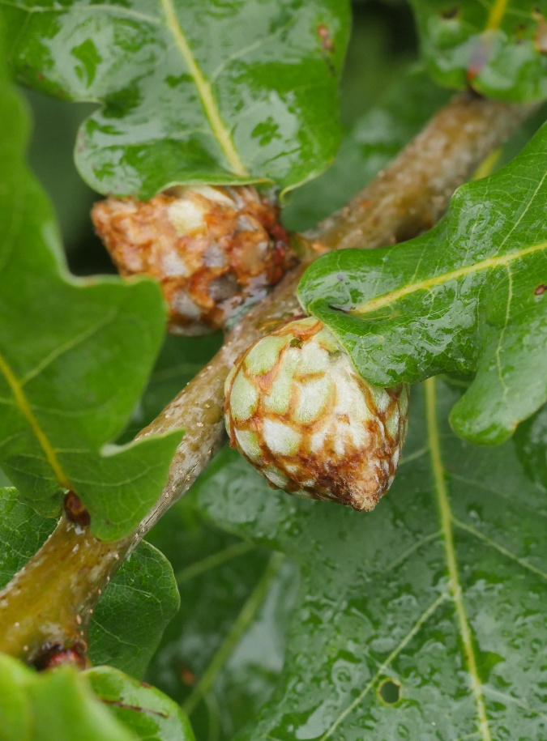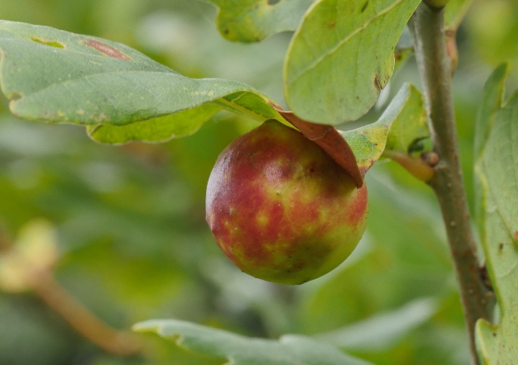
Andricus foecundatrix (Artichoke Gall) on Oak Cynips quercusfolii (Cherry Gall on Oak)

